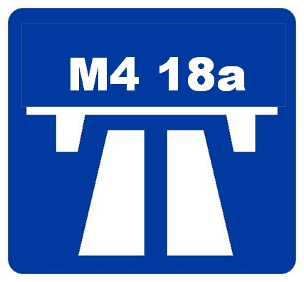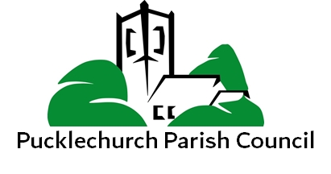
Call for volunteers

On Tuesday 1st of August the Parish Council will be holding a "call for volunteers" session at the Community Centre between 18:00 and 19:30.

Known roles:

Street champions -
Each street in the Parish has a champion who can deliver leaflets, consultation documents, or information sheets to that street.
They will be able to offer assistance if required by residents in the completion of paper or on line responses
They can help with the writing of objection letters
They will collect completed forms and return to the Parish Council who will forward to SGC
They will be a two way point of contact and link the residents to the Parish Council

Technical experts
Residents with specific skills relevant to this objection, engineering, road transport, biodiversity, mining, historical sites knowledge, consultation experience, protected species and there will be more.

Local business
To provide impact statements
To offer resources
To communicate through their network

I'm sure there will be more skills and capabilities that can be offered so please do not look at this list as inclusive.

